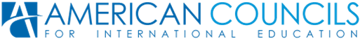
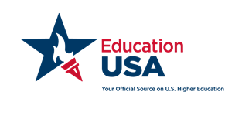

US Undergraduate Workshop
March 12, 2016!
Are you in the process of researching and applying to a U.S. University but lack resources and guidelines for finding the right U.S. University and decide on a major? EducationUSA is here to help! Join US Undergraduate Workshop this March to find out everything about US Schools with a specific major, field of study, the requirements, financial aid offered, and more!
Come to attend two-hour hands-on workshop to acquire all the skills necessary for finding the Best Fit School in the United States!
Requirements:
- Strong English Language skills;
- Strong Interest in applying to US schools;
When:
- Saturday, March 12th from 11:00am to 13:00pm
Where:
EducationUSA Advising Center in Turkmenistan
48A Gorogly St., 3rd Floor, Ashgabat 744036 Turkmenistan
T: (99312) 971016 ext.106
E: eac@americancouncilstm.org
Participation is free!

For more information please contact EductaionUSA Advising Center or visit our website at www.americancouncilstm.org

