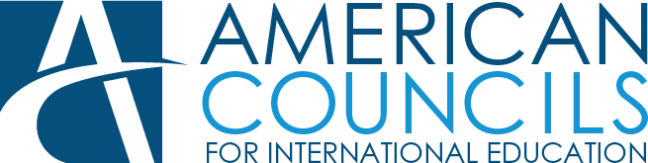

FLEX Program Intern

Ashgabat, Turkmenistan

Issue Date: April 6, 2023

Deadline for Application: April 21, 2023

**Position Description**

# Summary

FLEX Internship is designed for FLEX alumni, who are university/college students or for alumni, who have graduated from secondary school and aims at promoting the FLEX Program to high school students in the country as well as increasing Alumni engagement in their local community through organization of virtual/in-person activities and provision support to the younger Alumni in leading their independent projects.

FLEX Internship provides alumni of the FLEX program with 8 weeks (20 hrs. per week) internship that gives them real experience in event planning and organization. Alumni can identify the length of time they are able to commit to and then MUST commit to that entire time period. Interns who successfully complete their term will receive a honorarium and letter of recommendation.

# Duties and Responsibilities

* Assist with the FLEX Program promotion: conduct *My FLEX Experience*

presentations virtually and in-person at the American Center on monthly basis;

* Work with FLEX Alumni Coordinator on FLEX Alumni involvement in FLEX Recruitment;
* Advertise the FLEX Program on social media (IMO);
* Mentor and assist in the development of two major project each month led by junior FLEX Alumni;
* Prepare budgets for Junior FLEX Alumni projects;
* Translate the FLEX program news/FLEX Alumni articles for the American Councils website;
* Assist with designing the FLEX program promotion flyers in local languages for the Book Fairs and other events;
* Assist in maintaining an internal FLEX photo library;
* Collect, keep, and maintain a bi-weekly record on FLEX Alumni success stories;
* Provide logistical support to the American Councils staff;
* Assist FLEX Hub Director, in particular during PDO event;
* Assist in marketing of American Councils and FLEX Alumni projects;
* Assist American Councils staff in other areas as assigned.

# Required Skills and Competences:

1828 L Street N.W., Suite1200, Washington, D.C. 20036 **T** 202 833 7522 **F** 202 833 7523 [www.americancouncils.org](http://www.americancouncils.org/)

48a Gerogly St. Ashgabat, Turkmenistan 744036 **T** (99312) 36 90 16 [www.americancouncilstm.org](http://www.americancouncilstm.org/)

* Successfully participated in and completed the FLEX program;
* Turkmen citizenship;
* Strong leadership and ability to organize, encourage and motivate peers;
* Creativity, initiative, and problem-solving skills;
* Ability to manage time, respect for rules, accountability, and understanding of the need for quality in their work;
* Computer skills: MS Programs.

# Education and Experience

* FLEX alumni graduated from secondary school or currently in their 2nd, 3rd, or 4th year of university or secondary school graduates;
* High oral and written proficiency (fluency preferred) in Turkmen and/or Russian language, basic oral and written skills also a plus.
* Experience in social media marketing, activity/project organization;
* Previous experience in FLEX Alumni activities.

# Application Instructions

To apply, email a complete application package consisting of a 1) Application; 2) Resume/CV, 3) a letter of Recommendation to [kvintere@americancouncils.org](mailto:kvintere@americancouncils.org) Please include “FLEX Internship 2023” in the subject line of your email. For further information, please call +993-63-50-20-36/8-00-12-36-90-16.

# Application deadline: April 21, 2023