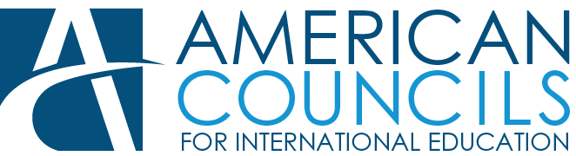

**Dashoguz American Corner Technical (IT) Assistant Position**

## Dashoguz, Turkmenistan

## Issue Date: August 22, 2023

## Deadline for Application: August 28, 2023 by 9:00 am.

## Position Description

**SUMMARY**

The Dashoguz American Corner Technical (IT) Assistant is a part time (20 hours/week) position based in Dashoguz, Turkmenistan. This position is responsible for overseeing the technical operations of the Dashoguz American Corner. The IT Assistant reports directly to the Manager of the Dashoguz American Corner but requires frequent coordination with the System Administrator in Turkmenistan, and American Councils staff.

**RESPONSIBILITIES**

* Oversee the technical operations of the American Corner in Dashoguz;
* Maintain and oversee the upkeep and operation of all computers and other technical equipment in the office;
* When required, install and configure hardware and software, and solve technical issues as they arise;
* Maintain technical equipment inventory;
* Request needed equipment to run the Dashoguz American Corner programs in a timely manner;
* The IT person is also expected to step outside of his/her formal role from time-to-time to support the team when physical help is needed around the office;
* Perform other related duties as required and assigned by your supervisor, System Administrator in Turkmenistan, and the Country Director.

**QUALIFICATIONS**

* Basic knowledge in local networks;
* Basic knowledge in hardware replacements/management/planning;
* Strong IT/computer skills;
* Previous related office experience preferable;
* Candidates should be mature individuals with a professional attitude;
* Higher education preferred but not necessary;
* Ability to work with a team;
* Turkmen citizenship.

In general, all American Councils staff members are expected to support a positive, team atmosphere and step outside of their formal roles from time-to-time to support the organization, special initiatives, or individual programs when needed.

**APPLICATION INSTRUCTIONS**

A complete application must include:

1. Resume/CV;
2. Cover Letter highlighting motivation for the position and **expected salary.**

Please email applications to [jobs@americancouncilstm.org](mailto:jobs@americancouncilstm.org) and CC [acmanager@americancouncilstm.org](mailto:acmanager@americancouncilstm.org) indicating **“Dashoguz American Corner Technical (IT) Assistant Position”** in the subject line of your email. The application should be received not later than *August* 2*8, 2023 by 9:00 a*m.

For information, please call (993-63) 50-20-36 or visit our website at <http://americancouncilstm.org/>

American Councils is a legal entity in Turkmenistan under the Foreign Assistance Agreement between the governments of the United States and Turkmenistan with the purpose of implementing US Embassy education and cultural exchange programs in Turkmenistan.